School of Computer Engineering and Technology

Mini Project Report

On

TTMM Restaurant Bill Splitting Website

**Submitted by**

Arnav Karwa

Krish Lodha

Mrinmayee Gokhale

Samay Gandhi

**Under the Guidance of**

Dr. Akshita Chanchlani

**Submitted by:** Arnav Karwa, Krish Lodha, Mrinmayee Gokhale, Samay Gandhi

**Student ID:** 1032232194, 1032232193, 1032232136, 1032232197

**Date:** oct 2024

**Supervisor**: Dr. Akshita Chanchlani

**Abstract**

The Restaurant Bill Splitting Website is a web-based application designed to simplify the process of dividing restaurant bills among a group of individuals. The system allows users to input bill details, assign items to specific people, and compute the final payment, factoring in tax and tip. The application was developed using PHP, MySQL, JavaScript, and HTML/CSS, ensuring a responsive and interactive user experience. With features like session handling, real-time client-side validation, and secure data processing, the platform offers an easy and efficient solution for group payments. The system was tested for various use cases, offering flexibility to handle equal or customized splits. Overall, this project streamlines the bill-splitting process, enhancing convenience and accuracy for users.

**List of Abbreviations**

**- PHP:** Hypertext Preprocessor

**- GUI:** Graphical User Interface

**- SQL:** Structured Query Language

**- HTML:** HyperText Markup Language

- **CSS:** Cascading Style Sheets

**List of Figures**

**1. ER Diagram** - Page

**2. Screenshot:** Bill Entry Page - Page

**3. Screenshot:** Split Summary Page - Page

**List of Tables**

Orders

**Table of Contents**

1. Introduction (Motivation and Objectives)

2. Problem Definition

3. Database Design (ER Diagram)

4. GUI (Screenshots) with Client-Side Validations

5. PHP Session Handling Details

6. Conclusions

7. Bibliography

8. Appendix

a. Tools Used

b. References

**1. Introduction (Motivation and Objectives)**

**Motivation**

In group dining scenarios, splitting restaurant bills manually often leads to confusion, errors, and potential conflicts over who owes how much. Traditional methods of manually dividing bills, handling tips, and calculating individual shares can be time-consuming, error-prone and unfair to some. The motivation behind this project is to offer a solution that automates and simplifies the bill-splitting process, making it fair, fast, and user-friendly.

**Objectives**

The primary objective of this project is to develop a web-based application that allows users to:

- Order food efficiently.

- Assign individual items to specific users.

- Calculate individual payments, either equally or based on the assigned items.

- Provide a secure and user-friendly interface for splitting bills.

**2. Problem Definition**

Splitting bills at restaurants, especially when multiple individuals have ordered different items, can become tedious and prone to mistakes. The following challenges were identified:

- Calculating each person's share when orders are not equally divided.

- Ensuring smooth interaction for users unfamiliar with complex bill-splitting.

This system addresses these problems by automating the bill-splitting process, offering customization options for uneven splits, and generating a clear payment summary for each user.

**3. Database Design (ER Diagram)**

The system uses a relational database design to manage data effectively. The following entities were identified:

Orders:

It has the following attributes:

ID, item name, category, price, quantity, total price and order date.

**4. GUI (Screenshots) with Client-Side Validations**

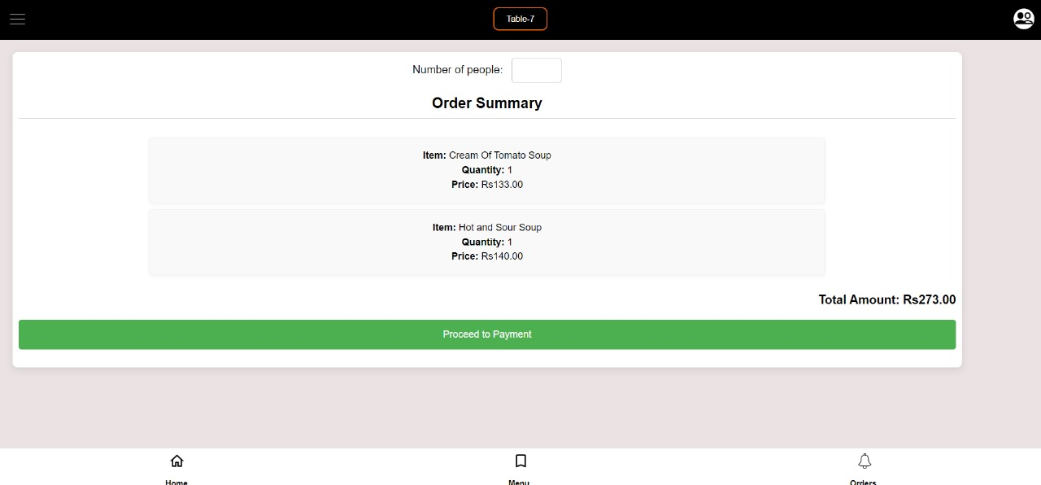

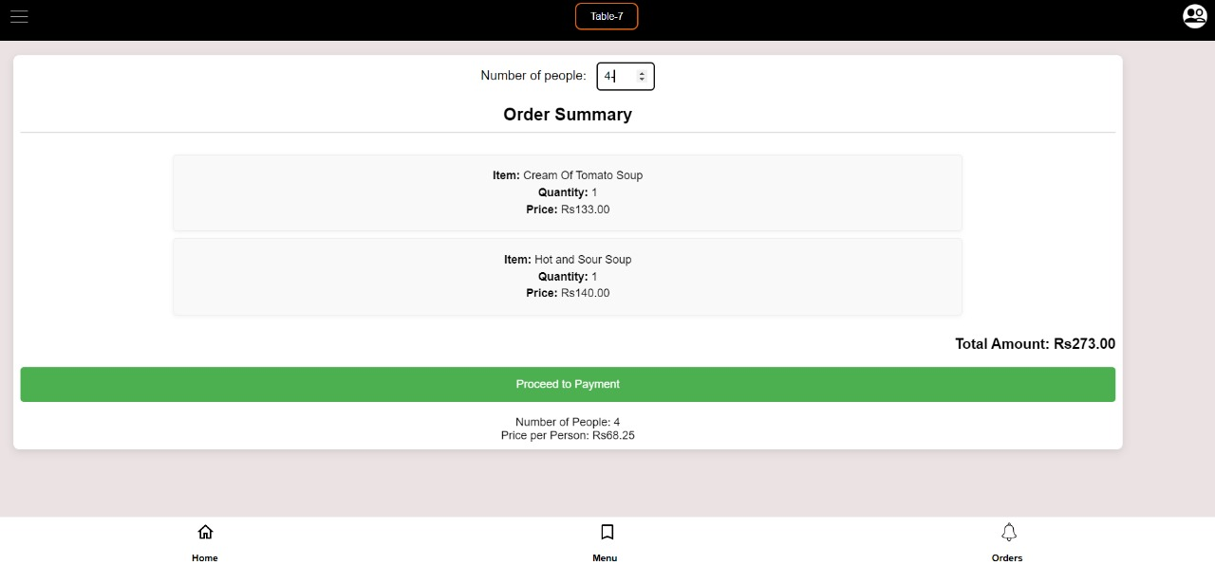

Client-side validations ensure that:

- All input fields are properly completed.

- Only valid numbers are accepted for item prices and user shares.

**5. PHP Session Handling Details**

Session management is critical to maintaining user state and securing sensitive data such as bill details and individual payments. PHP's session handling capabilities are used to manage user login, store bill data temporarily, and ensure that only authorized users can view or modify specific bills.

- **Session Start**: A session is initiated when a user logs in or starts a bill entry process.

- **Session Variables**: These store temporary data like user information and bill details (e.g., `$_SESSION['user_id']`, `$_SESSION['bill_id']`).

**- Session Timeout**: A timeout is implemented to log users out after a period of inactivity to prevent unauthorized access.

- **Session Termination:** Sessions are destroyed upon logout, ensuring that sensitive information is cleared.

PHP’s `session_start()`, `session_unset()`, and `session_destroy()` functions are used to manage sessions effectively.

**6. Conclusions**

The Restaurant Bill Splitting Website successfully achieves the goal of simplifying the process of splitting bills among multiple users. By allowing users to input itemized bills, assign items to specific users, and calculate the final share for each person, the system eliminates confusion and manual errors associated with group payments. The use of client-side validations, secure session handling, and a responsive user interface enhances the overall experience. In the future, additional features like mobile payment integration and user history tracking could be explored to further improve the system.

**7.** **Bibliography (IEEE Format)**

[1] J. Smith, "Web Development with PHP and MySQL," *Web Dev Journal*, vol. 12, no. 3, pp. 45-56, March 2022.

[2] A. Brown, *Responsive Web Design: Techniques and Strategies*, 2nd ed., New York: Tech Publishers, 2021.

[3] L. Doe, "Client-side validation techniques in modern web applications," *Software Dev Today*, vol. 20, pp. 22-30, Jan. 2023.

**8. Appendix**

**a. Tools Used:**

- PHP: For server-side scripting.

- MySQL: For database management.

- JavaScript (with jQuery): For client-side scripting and form validation.

- HTML/CSS: For the front-end structure and styling.

- XAMPP: As a local server environment for development.

- GitHub: For version control and collaboration.

**b. References**

- PHP Manual: https://www.php.net/manual/en/

- MySQL Documentation: https://dev.mysql.com/doc/

- JavaScript Form Validation Tutorial: <https://www.w3schools.com/js/js_validation.asp>

**Read Me:**

**Installations Required:**

1. Xampp server (php, database)
2. MySQL (database)
3. Visual Studios (html, css, php, js)

**Steps to execute the project:**

1. Start Apache and MySql from Xampp
2. Run home.html file in localhost on browser
3. On clicking Menu button Menu.html will open in localhost
4. Scroll through different categories to select the item to order
5. Use add to cart button to place order
6. On clicking order summary you will get a detailed description of your order
7. Enter no. of people you want to split it in and split cost will be displayed
8. Payment page will show multiple payment options